**BDAT 1000 Wednesday Data Manipulation Techniques** **Name**: Shubham Chawla

*Assignment 1* **Student ID**: 200493036

**Cleaning done in excel before inserting the data into the database**

1. Modified the Names of the columns for reducing the size and increasing readability.
2. Standardized Cases, For example: INDIAN, indian to Indian, Dogs, Dog, dogs, dog to Dog etc.
3. Capitalized the first letter of fields, For example: jay to Jay, tiktok to Tiktok etc.
4. Removed unnecessary delimiters. For example: Paris, South Korea… to Paris, South Korea, ‘/’, ‘(‘
5. Assumptions made for column – (Most Hated Lecture Time): Early Morning – 10:00, Evening – 17:00, Last Slot – 19:00
6. Assumptions in Date of Acceptance: Year = 2021, 01 Day if only month is mentioned, last week of July = Monday (27th July)
7. Grammar Check
8. Assigned same value to similar field, for example: (own startup, mine startup, startup to Startup), (Driving, Long Driving) – Driving
9. Replacing NULLS or EMPTY Values with ‘NA’

**Abbreviations used in this document PK – Primary Key, FK- Foreign Key**

**Task 1 – Create Database**

Created Database – Assignment_1 Successfully.

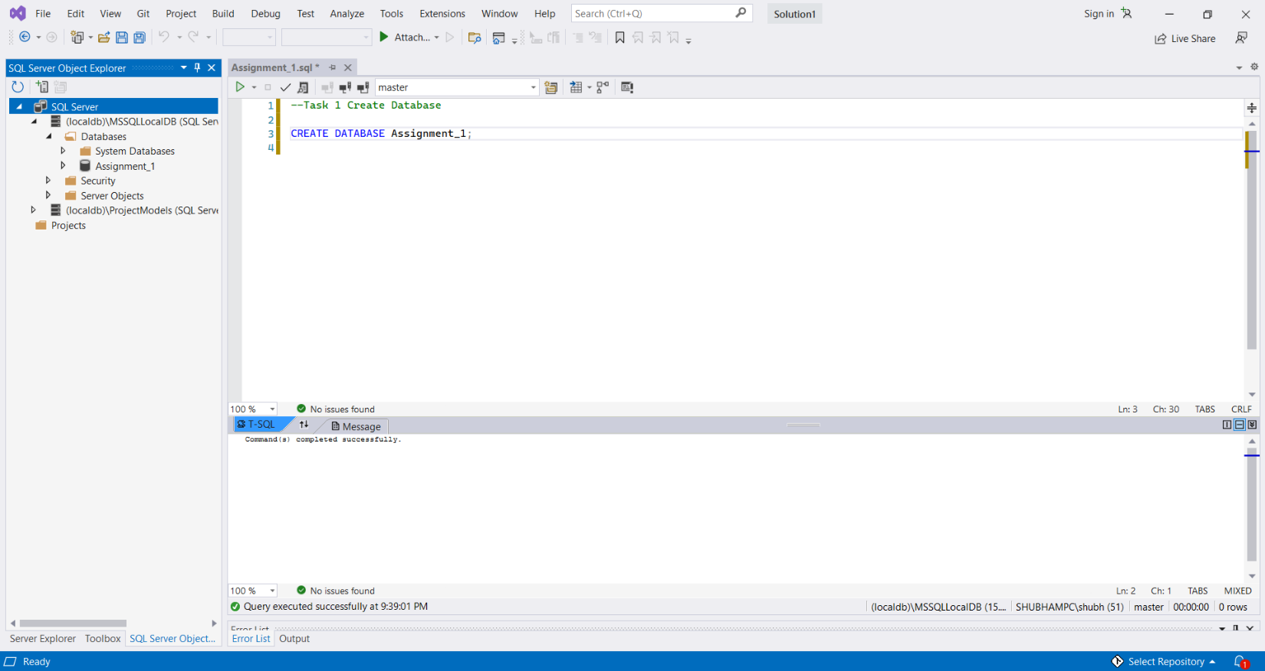

Used **‘USE’** command to change the database from master to Assignment_1.

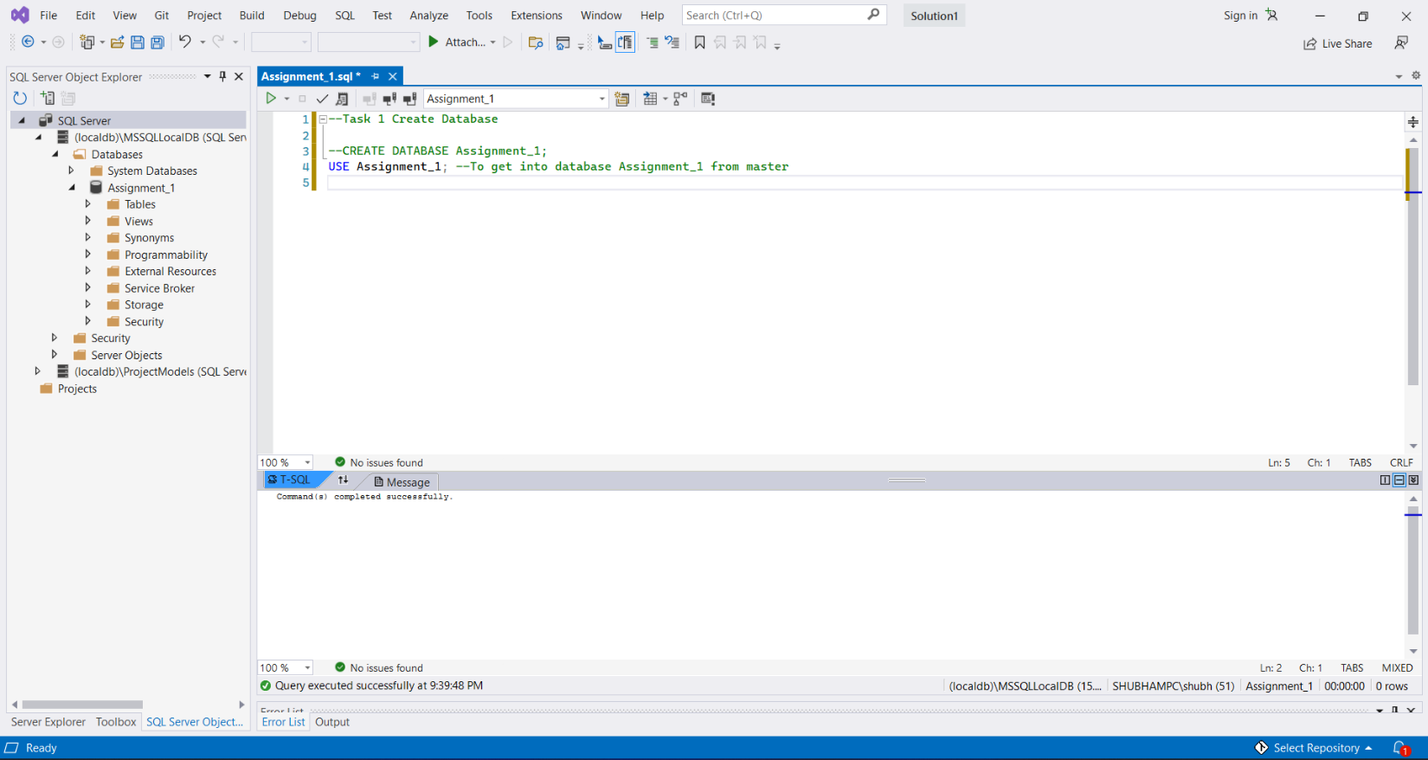

**Task 2 – Create Table**

Created Table ‘**StudentDetails’** after performing necessary cleaning operations in the excel file as mentioned above.

Used multiple data types, for example **varchar, char, time** and **date.**

Applied **NULLS and NOT NULLS** wherever necessary. Table consists of **15 columns.**

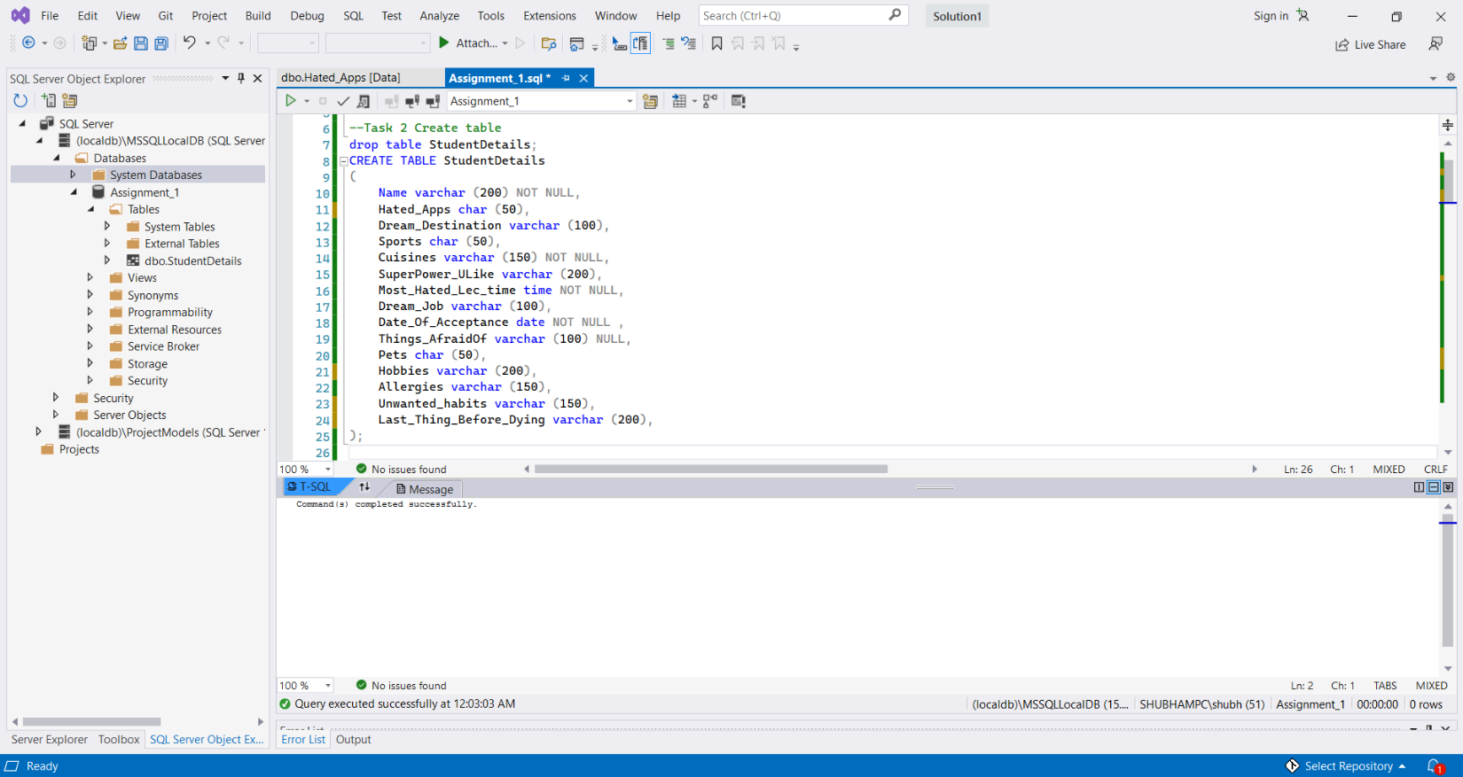

**Task 3 – Insert Values from Excel File into Database Assignment_1**

Inserted all the data from Excel File into the Assignment_1 Database using **INSERT** Command. As we can see, **19 rows were inserted successfully**.

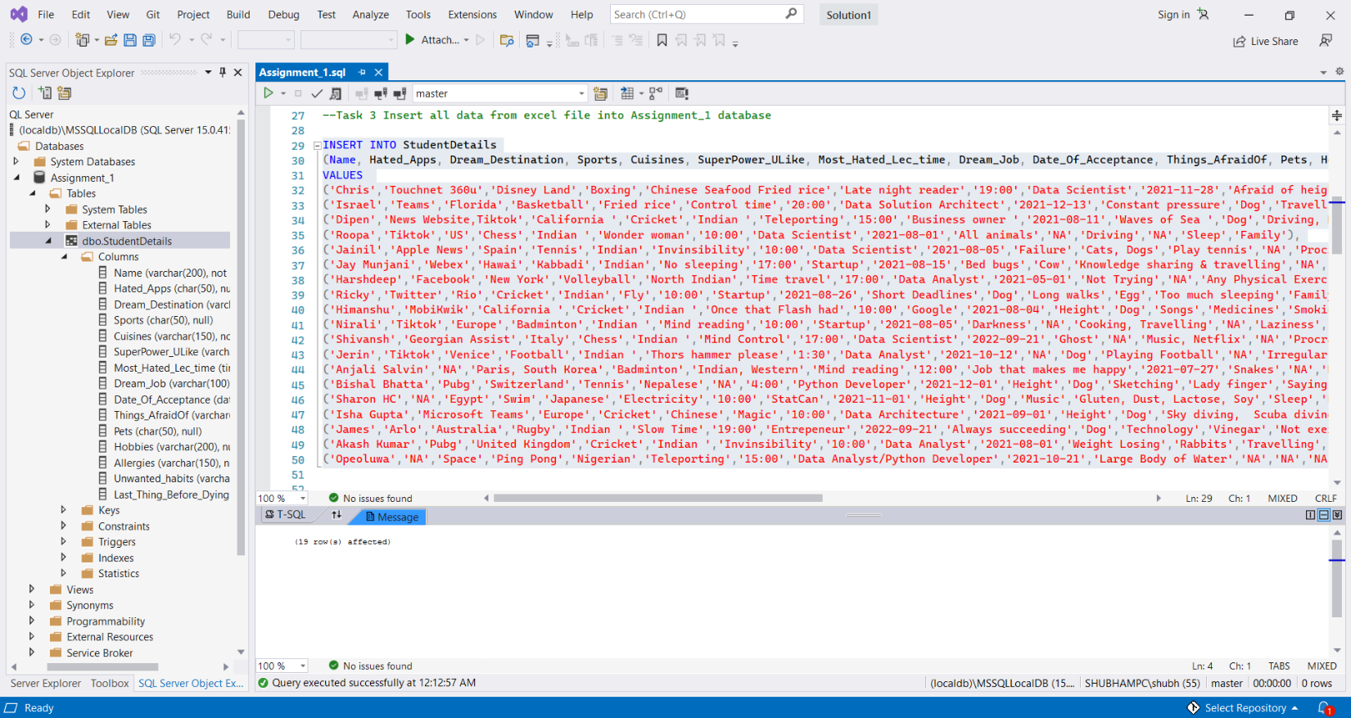

The Image below shows the table with the data we just inserted with 15 columns and 19 rows.

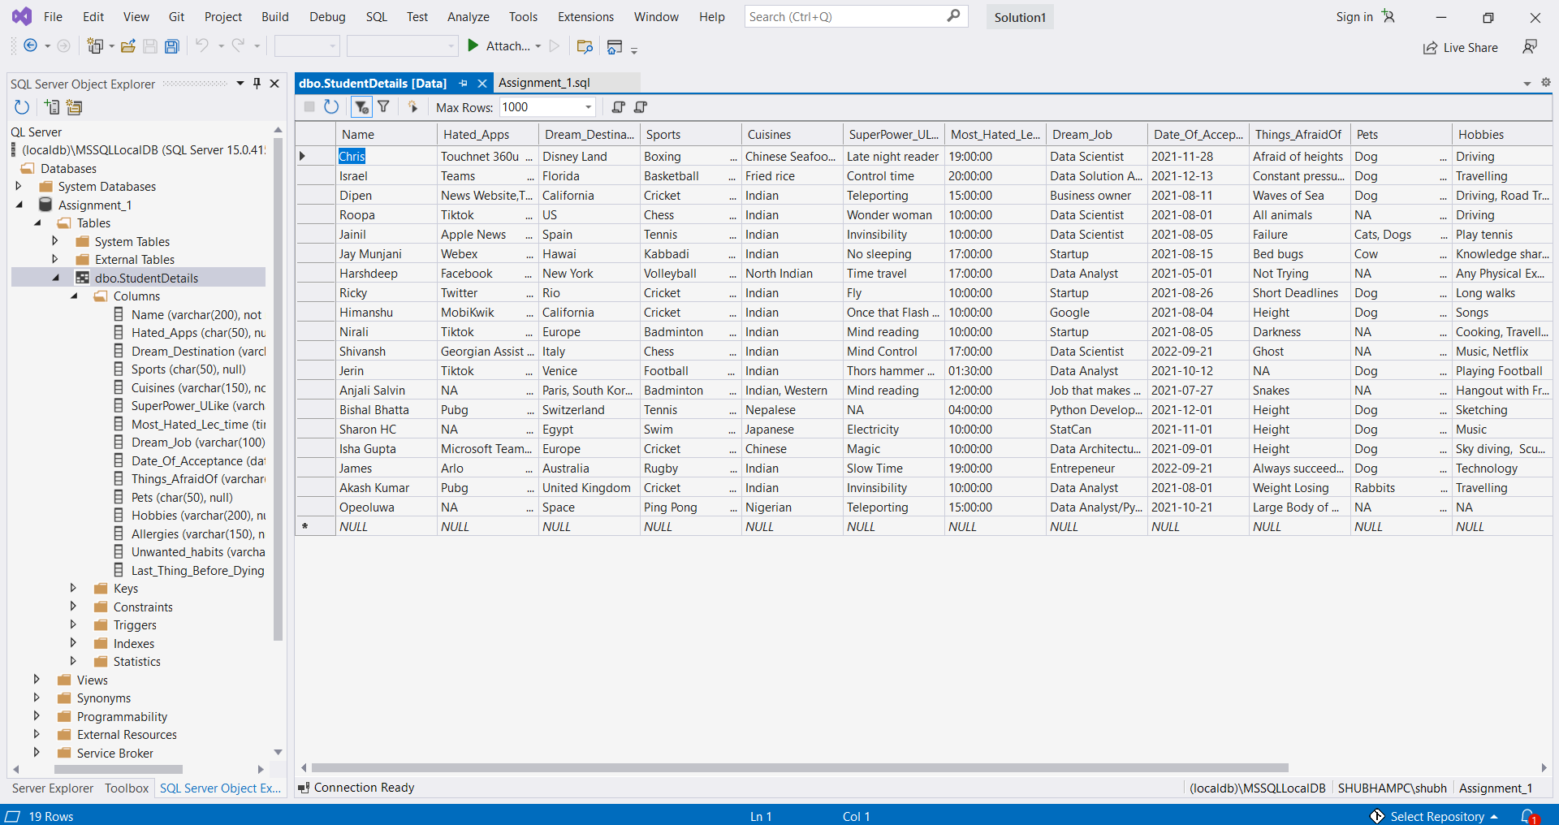

**Normalization Process**

1. Adding a primary key to the table **StudentDetails** – StudentID

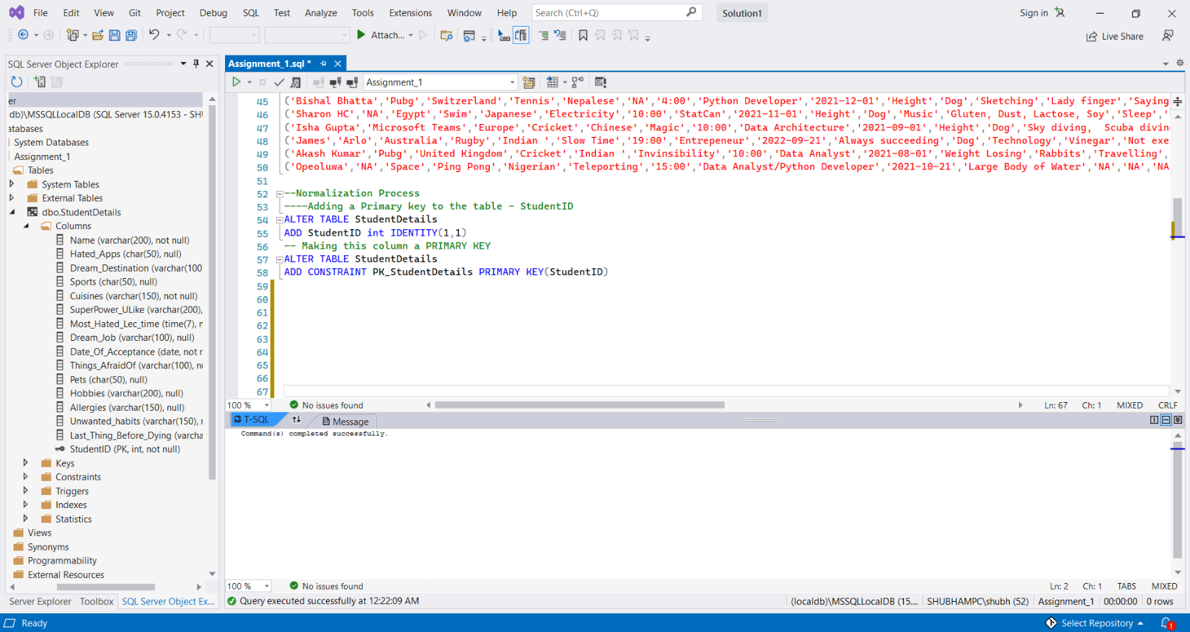

1. Splitting Name column into FName and LName using PARSE command using space as a delimiter. To do this I will make another table (StudentDetails_1) and transfer all the data from StudentDetails table to StudentDetails_1.

(https://www.mssqltips.com/sqlservertip/6321/split-delimited-string-into-columns-in-sql-server-with-parsename/)

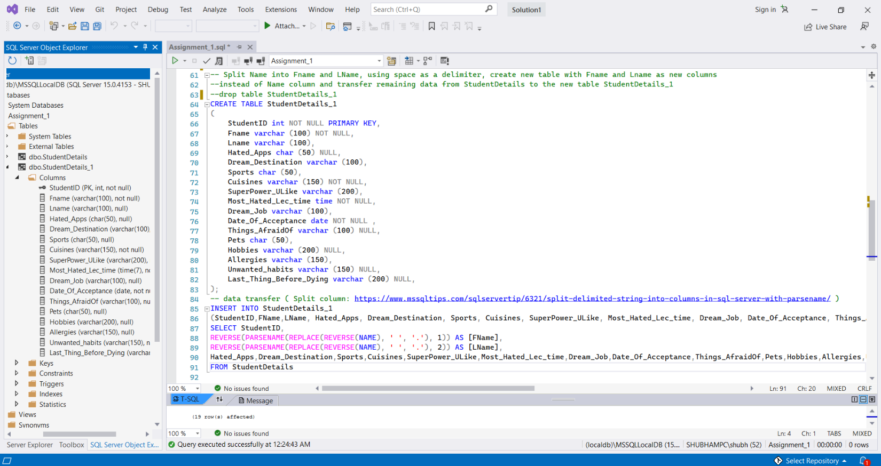

We can see in the below image that the Name column has been splitted into FName and LName successfully. 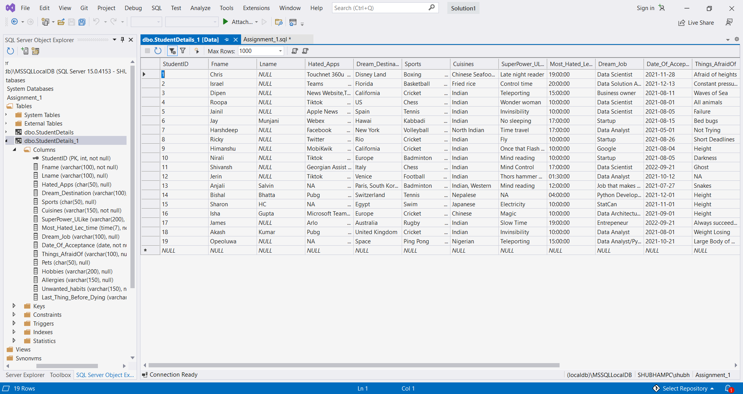

Next, I will create 2 Tables for each column that has redundancy or has multi values attributes.

For example, **‘Sports’** column has the value **Cricket** **repeating 4 times,** so I will create a Sports table (SID-PK, Sports) and MappingSports Table (MSID – PK, StudentID-FK, SID-FK). MappingSports table contains the foreign key references to the StudentDetails_1 table and Sports table. You can see the database design below. This will happen for all the other columns as well that shows redundancy as well as multi-value attributes.

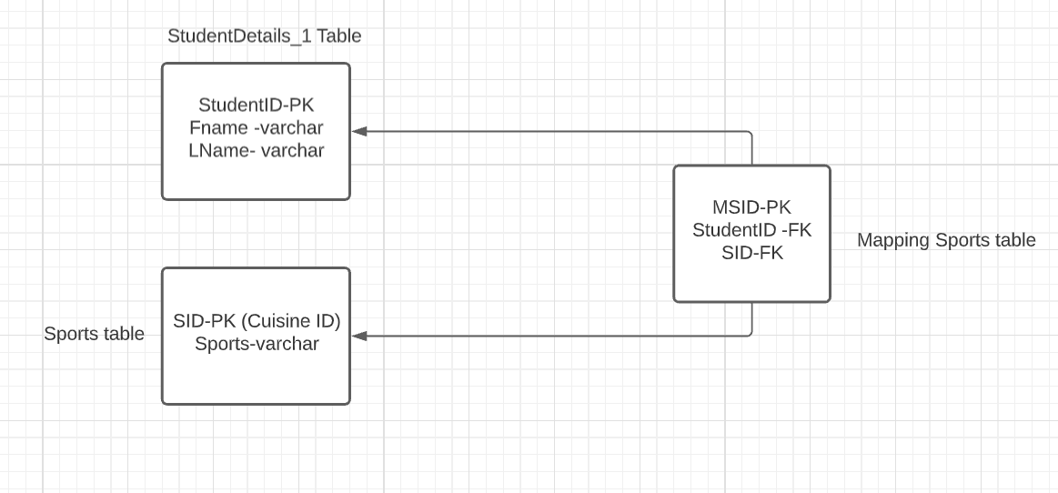

1. Now looking at the column **Sports**, there is some redundancy present. To get rid of the redundancy, we will create two tables and insert values in those tables and modify StudentDetails_1 table

* Sports table – SID (Sports ID) – PK, Sports
* MappingSports table – MSID (Mapping Sports ID)-PK, StudentID -FK, SID – FK

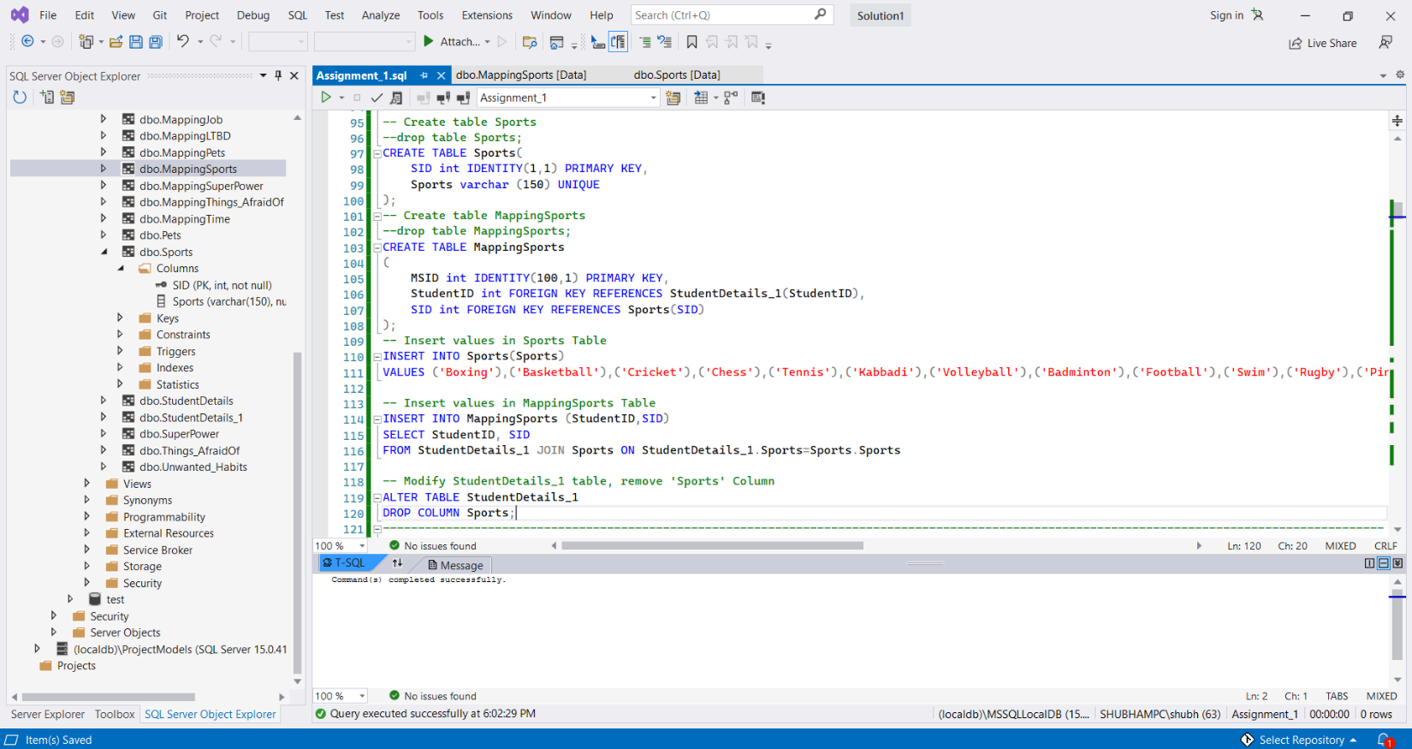

Tables **Sports** and **MappingSports** are shown below,

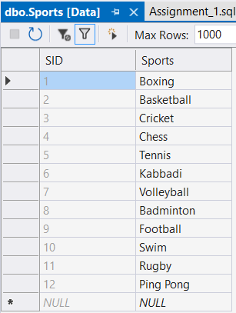 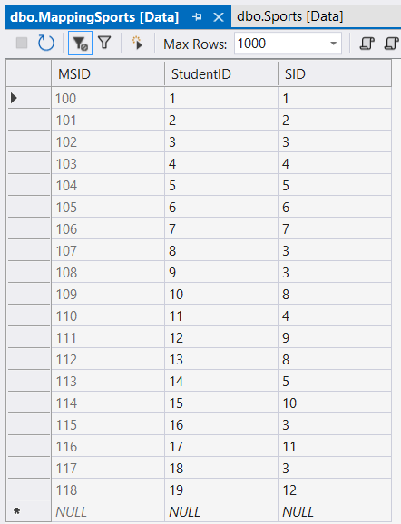

1. Similarly looking at the column **Most_Hated_Lec_Time**, there is redundancy present. We will create two tables and insert values in those tables and modify StudentDetails_1 table by removing **Most_Hated_Lec_Time** column.

* Hated_Lec_Time table – TID (Time ID) – PK, Lec_Time
* MappingTime table – MTID (Mapping Time ID)-PK, StudentID -FK, TID – FK

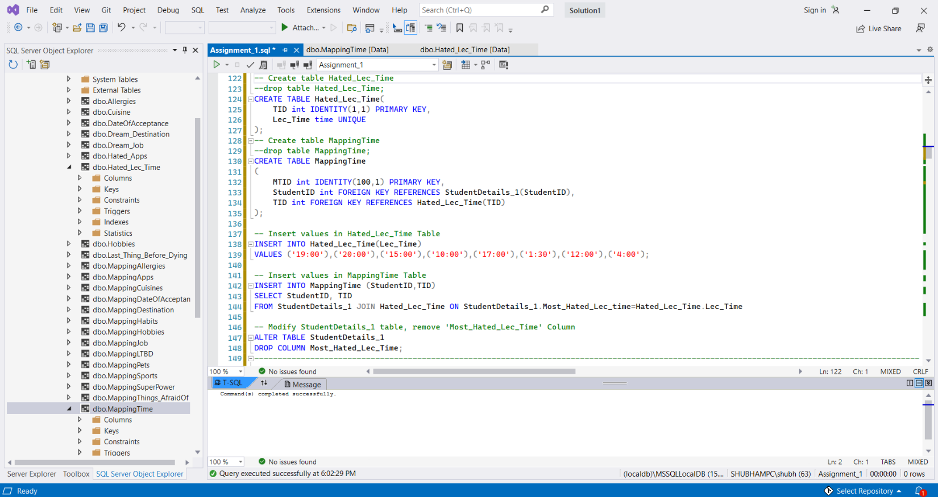

Table **Hated_Lec_Time** and **MappingTime** are shown below.

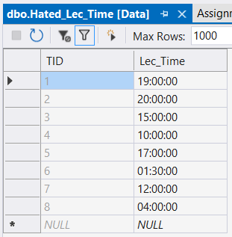 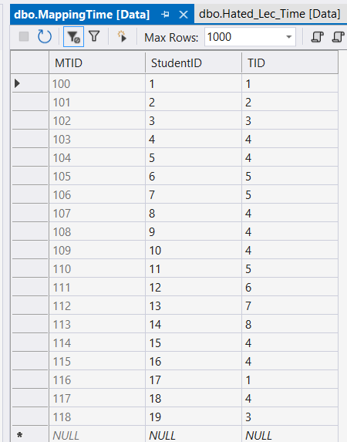

1. Now looking at the column **Super_Power_ULike**, there is some redundancy present. To get rid of the redundancy, we will create two tables and insert values in those tables and modify StudentDetails_1 table

* SuperPower table – SPID (SuperPower ID) – PK, SuperPower
* MappingSuperPower table – MSPID (Mapping SuperPower ID)-PK, StudentID -FK, SPID – FK

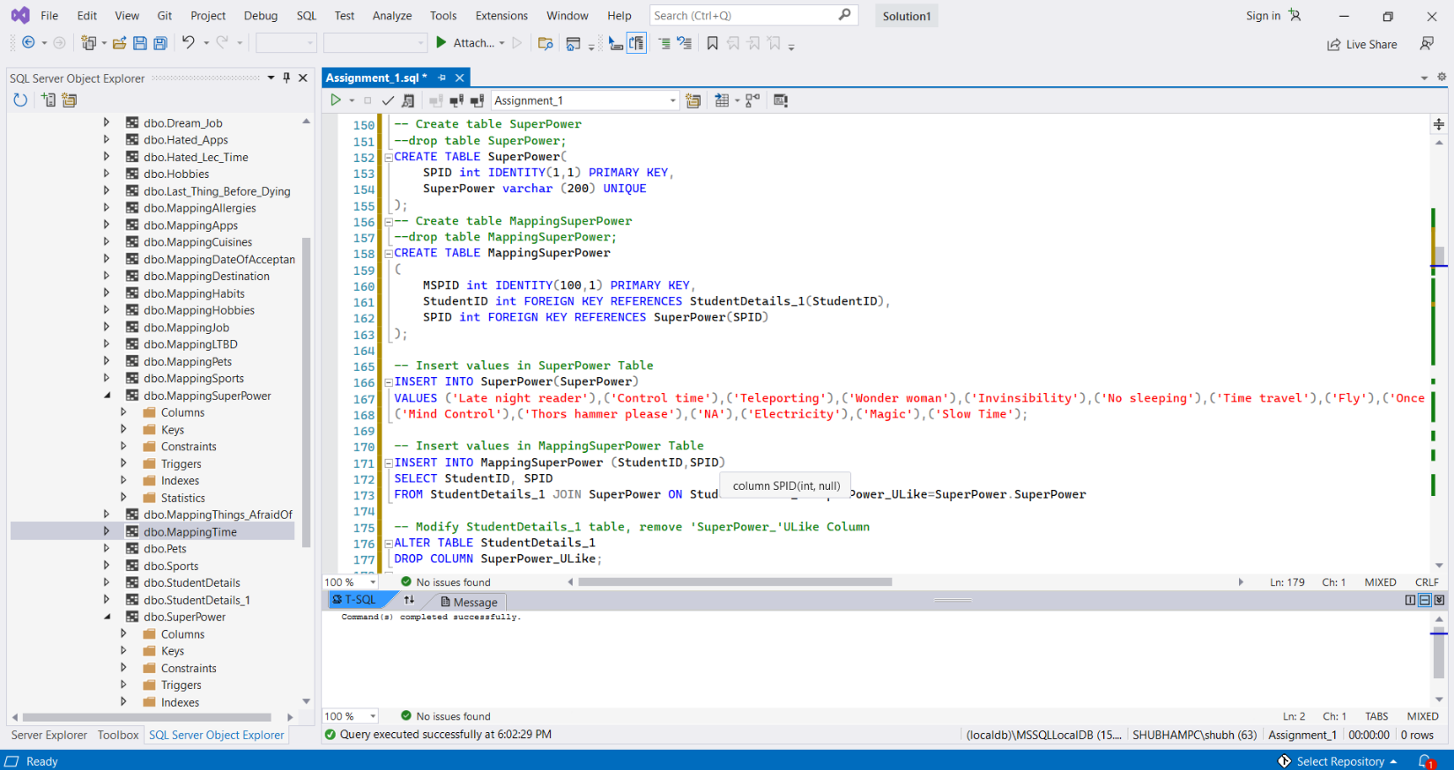

**SuperPower** and **MappingSuperPower** are shown below.

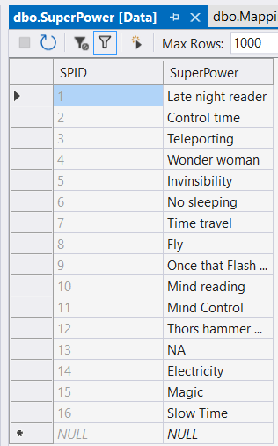 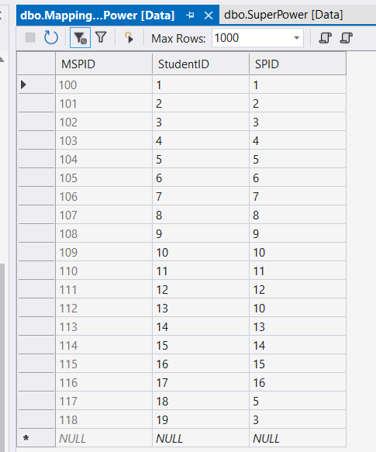

1. Now looking at the column **Dream_Destination**, there is some redundancy present. To get rid of the redundancy, we will create two tables and insert values in those tables and modify StudentDetails_1 table

* Dream_Destination table – DID (Destination ID) – PK, Destination
* MappingDestination table – MDID (Mapping Destination ID)-PK, StudentID -FK, DID – FK

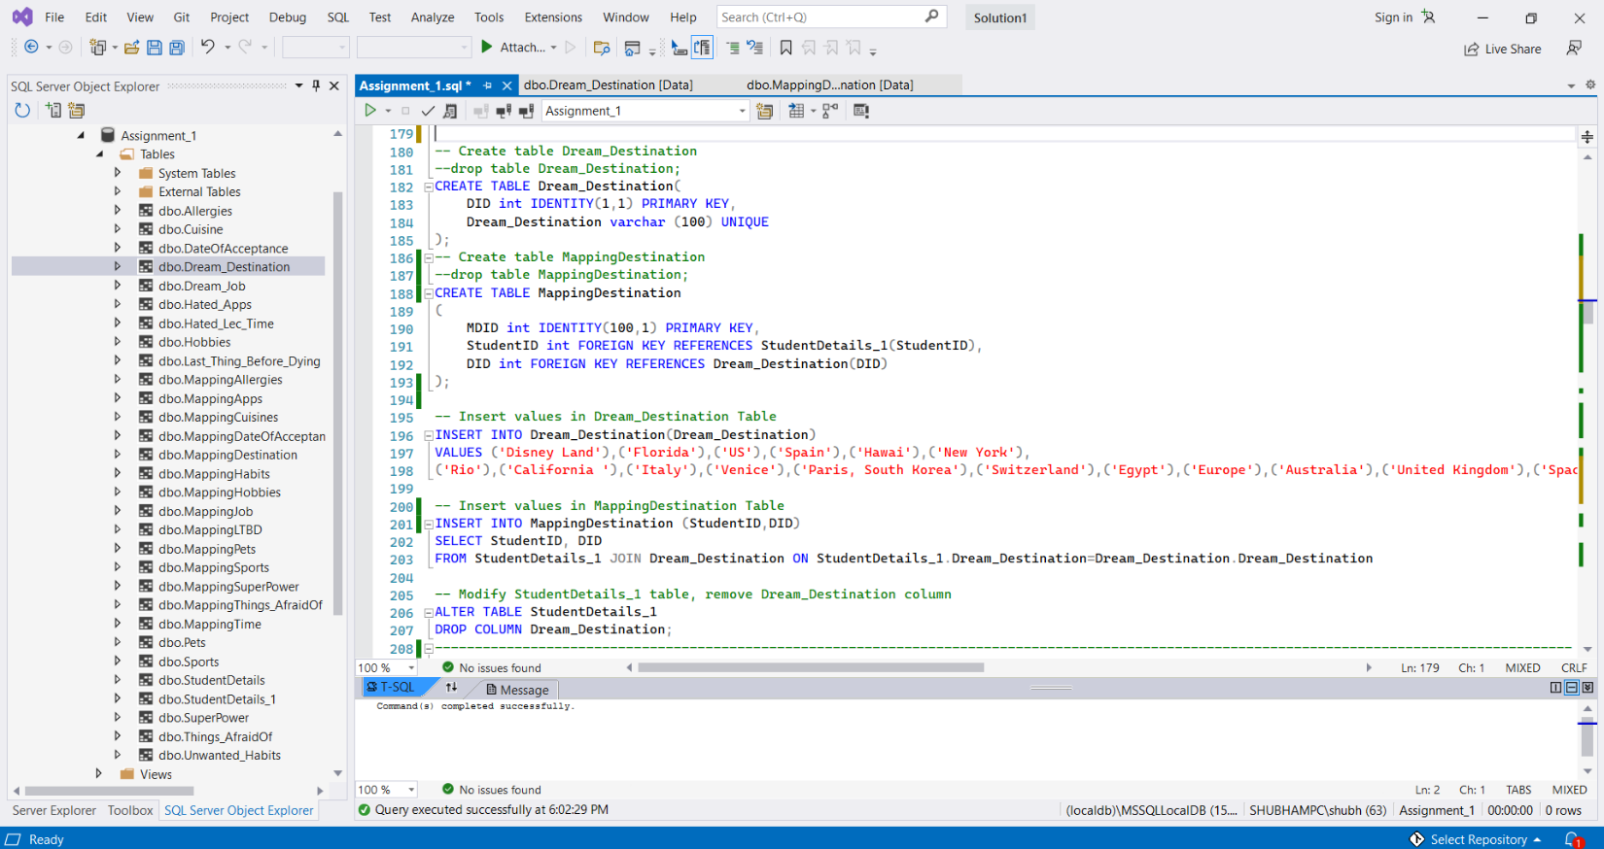

**Dream_Destination** table and **MappingDestination** table are shown below.

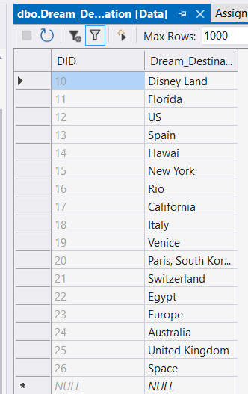 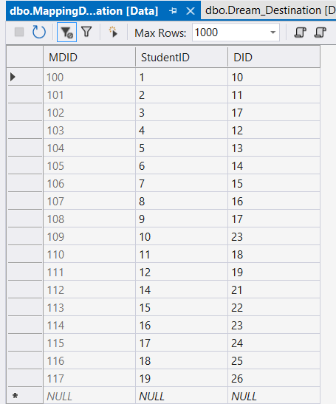

1. Now looking at the column **Dream_Job**, there is some redundancy present. To get rid of the redundancy, we will create two tables and insert values in those tables and modify StudentDetails_1 table

* Dream_Job table – JID (Job ID) – PK, Dream_Job
* MappingJob table – MJID (Mapping Job ID)-PK, StudentID -FK, JID – FK

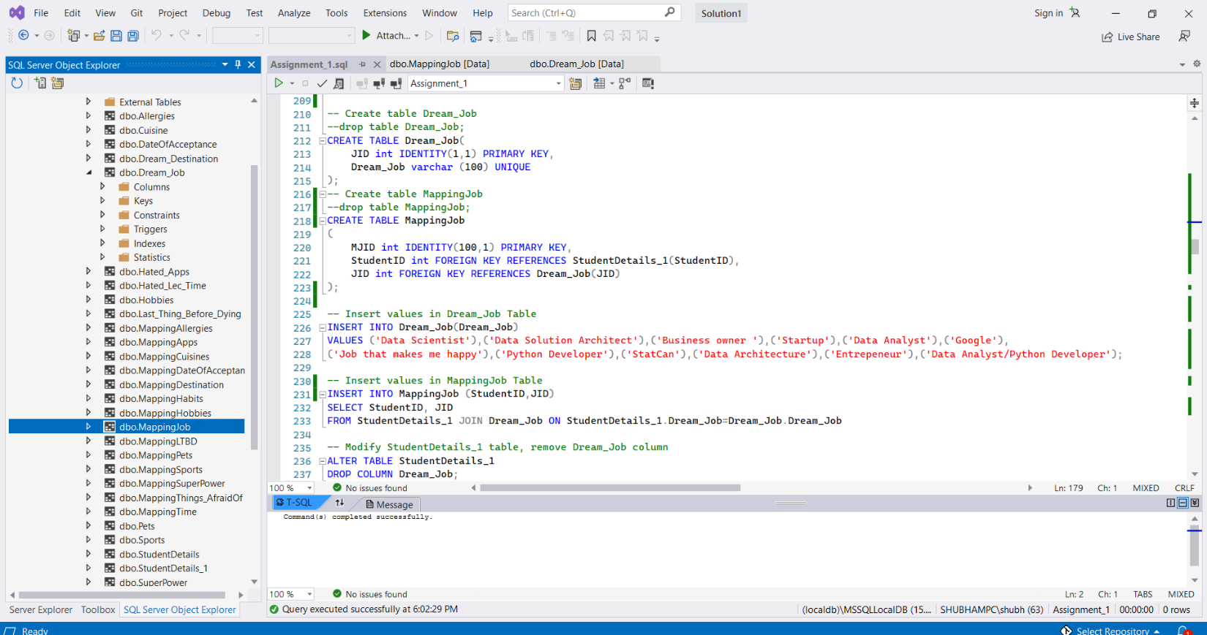

**Dream_Job** and **MappingJob** table are shown below,

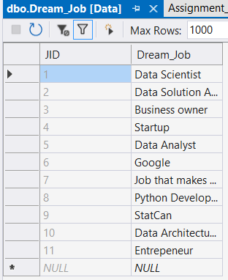 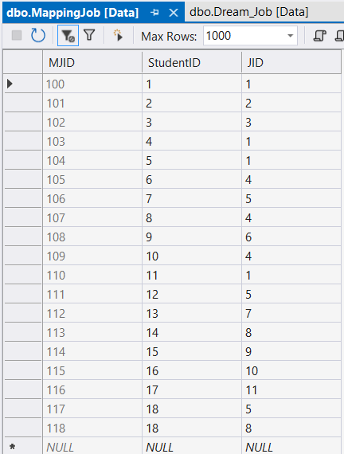

1. Now looking at the column **Things_AfraidOf**, there is some redundancy present. To get rid of the redundancy, we will create two tables and insert values in those tables and modify StudentDetails_1 table

* **Things_AfraidOf** table – Things_ID (Things ID) – PK, Things_AfraidOf
* MappingThings_AfraidOf table – MTAOID (Mapping Things Afraid of ID)-PK, StudentID -FK, Things_ID – FK

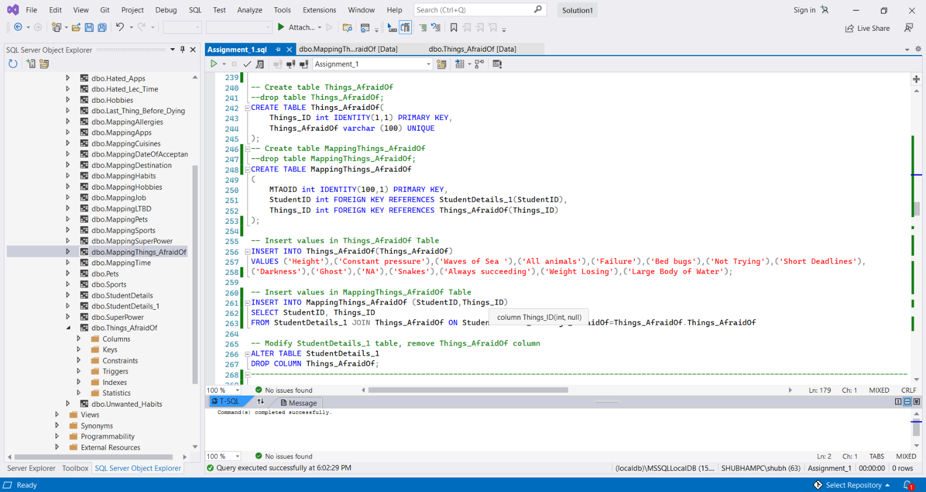

**Things_AfraidOf** and **Mapping Things_AfraidOf table** are shown below.

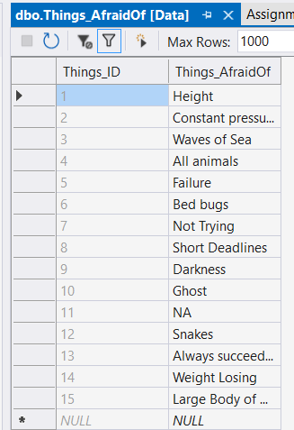 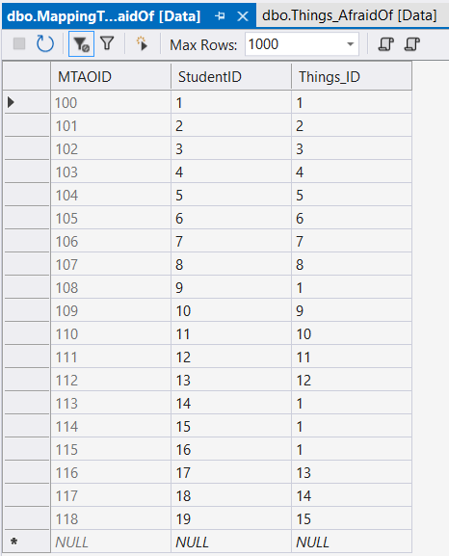

1. Now looking at the column **Pets**, there is some redundancy present. To get rid of the redundancy, we will create two tables and insert values in those tables and modify StudentDetails_1 table

* **Pets** table – Pets_ID (Pets ID) – PK, Pets
* MappingPets table – MPetsID (Mapping Pets ID)-PK, StudentID -FK, Pets_ID – FK

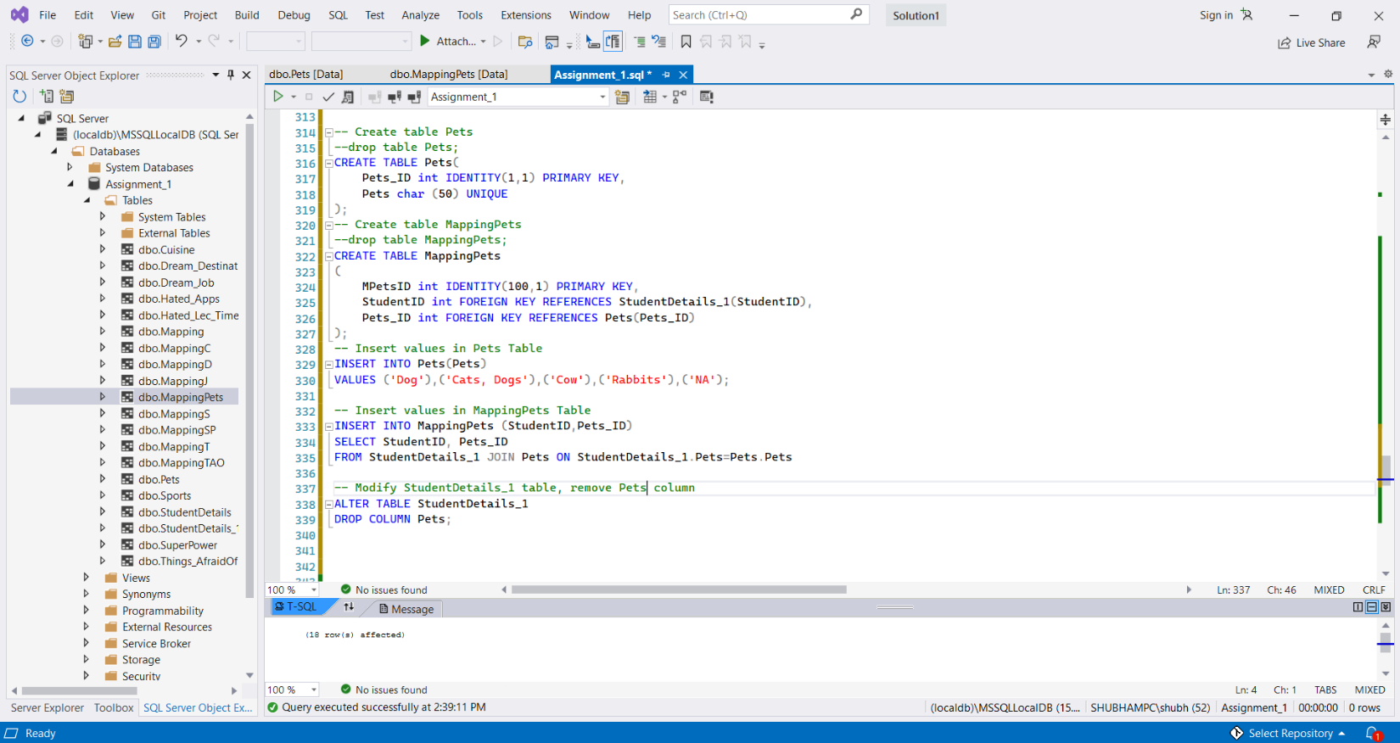

**Pets** and **MappingPets** table shown below,

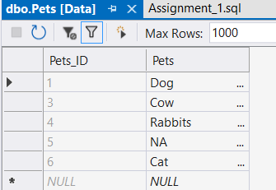 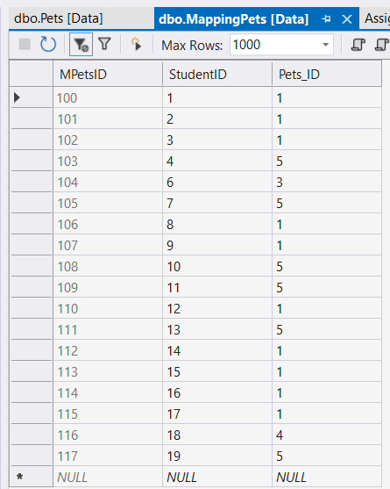

1. Now looking at the column **Unwanted_habits**, there is some redundancy present. To get rid of the redundancy, we will create two tables and insert values in those tables and modify StudentDetails_1 table

* **Unwanted_Habits** table – Habit_ID (Pets ID) – PK, Unwanted_habits
* MappingHabits table – MHabit_ID (Mapping Habit ID)-PK, StudentID -FK, Habit_ID – FK

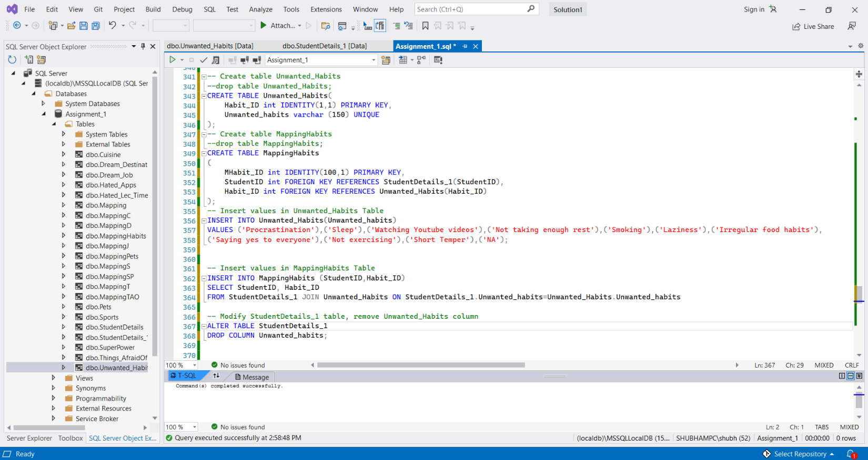

**Unwanted_Habits** table and **MappingHabit** table are shown below,

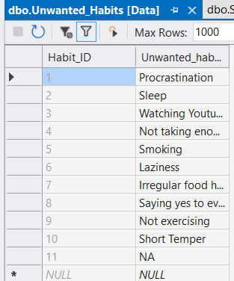 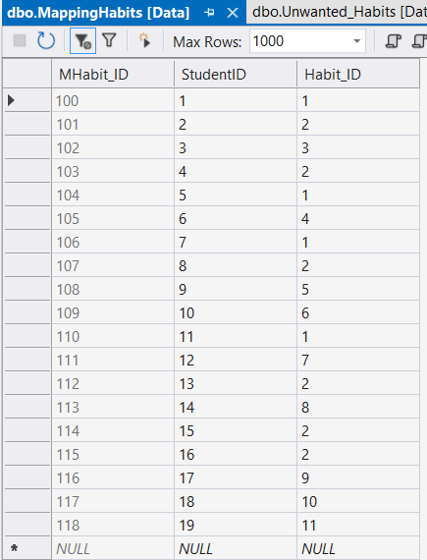

1. Now looking at the column **Date_Of_Acceptance**, there is some redundancy present. To get rid of the redundancy, we will create two tables and insert values in those tables and modify StudentDetails_1 table

* **DateOfAcceptance** table – DOA_ID (Date of Acceptance ID)– PK, DOA
* Mapping **DateOfAcceptance** table – MDOA_ID (Mapping **Date Of Acceptance** ID)-PK, StudentID -FK, DOA_ID – FK

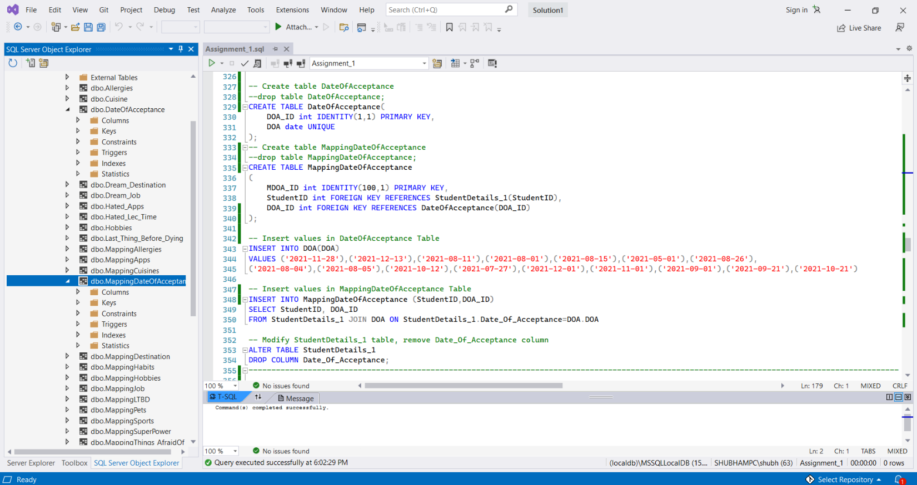

**DateOfAcceptance table and Mapping DateOfAcceptance** table are shown below,

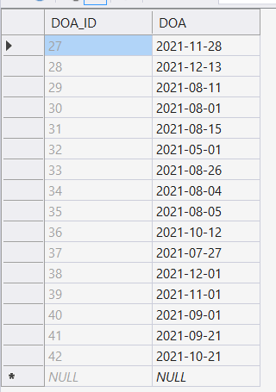 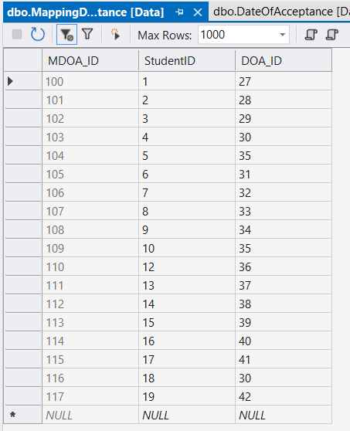

1. Now looking at the column **Last_Thing_Before_Dying**, there is some redundancy present. To get rid of the redundancy, we will create two tables and insert values in those tables and modify StudentDetails_1 table

* **Last_Thing_Before_Dying** table – LTBD_ID (**Last_Thing_Before_Dying** ID)– PK, **Last_Thing_Before_Dying**
* MappingLTBD table – MLTBD_ID (Mapping **Last_Thing_Before_Dying** ID)-PK, StudentID -FK, LTBD_ID – FK

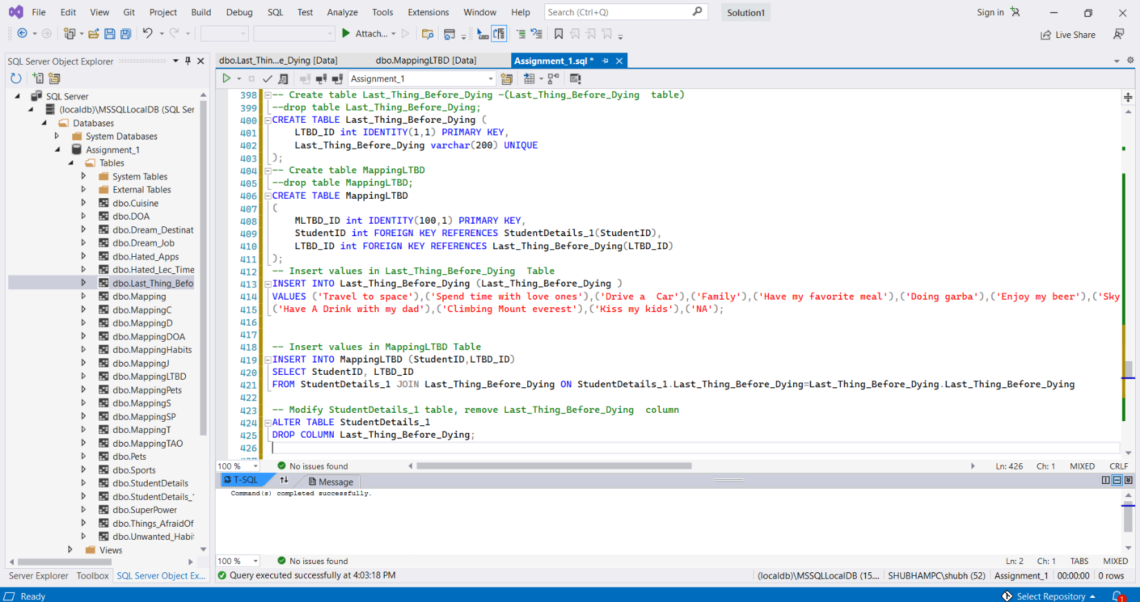

**Last_Thing_Before_Dying and MappingLTBD table are shown below,**

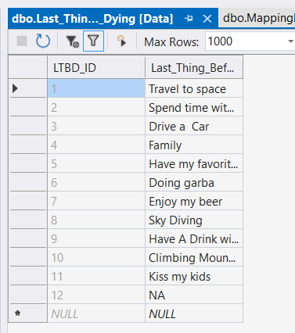 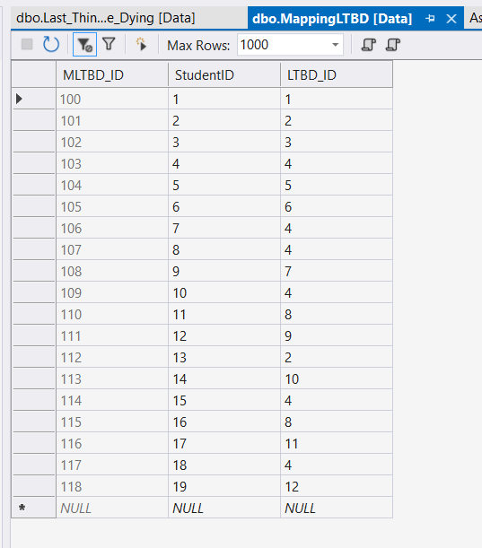

1. Now we will remove **multi-value attributes** or groupings from our latest table StudentDetails_1. In column **‘Hated_Apps’** we can see that Dipen has **2 different apps that he hates** and values such as **‘Tiktok’, etc are repeating**. In order to normalize our table further, we will create 2 new tables – ‘**Hated_Apps’ Table** and another table called **‘Mapping’** which will maintain **many to many** relationships between these 2 tables (StudentDetails_1 and Hated_Apps) and will contain a reference to the AppID Column in the Hated_Apps table as well as StudentID column in the StudentDetails_1 table.

* Hated_Apps Table: AppID -PK, HApps (Hated Apps)
* Mapping Table: MID (Mapping ID)-PK, StudentID-FK, AppID-FK

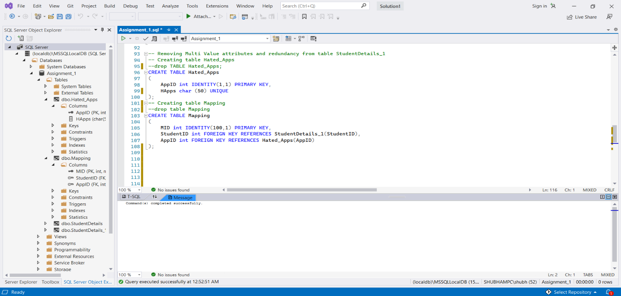

Now we will insert values in ‘Hated_Apps’ table and ‘Mapping’ table and modify our StudentsDetails_1 table by removing the ‘Hated_Apps’ column.

**Used select command while inserting data into Mapping table as it references StudentDetails_1 and Hated_Apps table.**

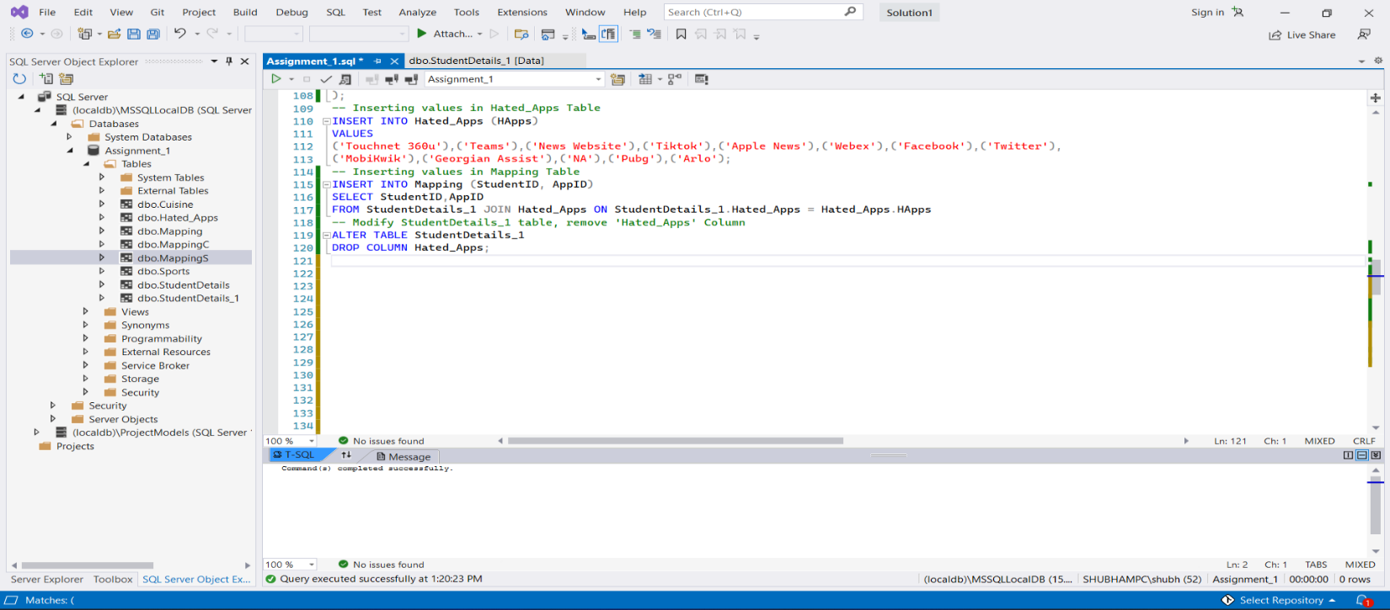

Hated_Apps and Mapping Table are shows below.

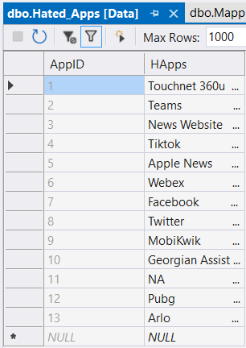 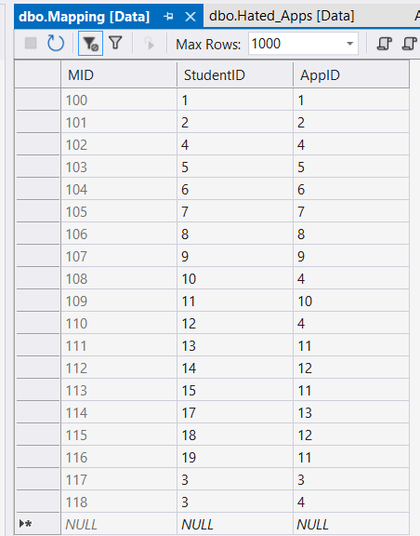

1. Similarly, looking at the column **‘Cuisines’**, there are multi value fields and redundancy present. We will create two tables and insert values in those tables and modify StudentDetails_1 table by removing **‘Cuisines’** Column.

* Cuisine table – CID (Cuisine ID) – PK, Cuisines
* MappingC table – MCID (Mapping ID)-PK, StudentID -FK, CID – FK

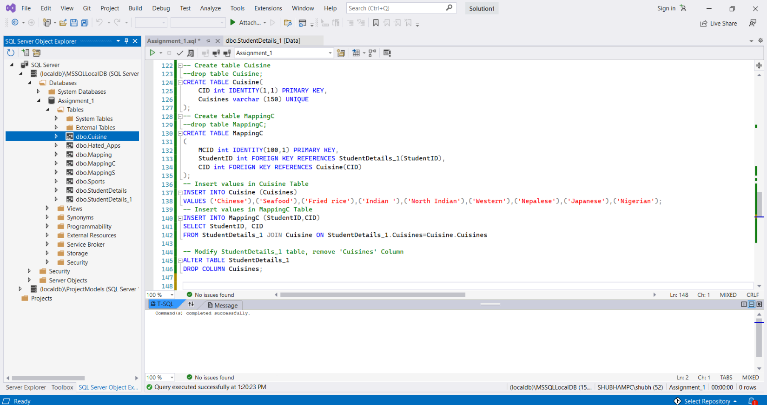

**Used select command while inserting data into MappingC table as it references StudentDetails_1 and Cuisines table.**

The tables Cuisines and MappingC are shown below,

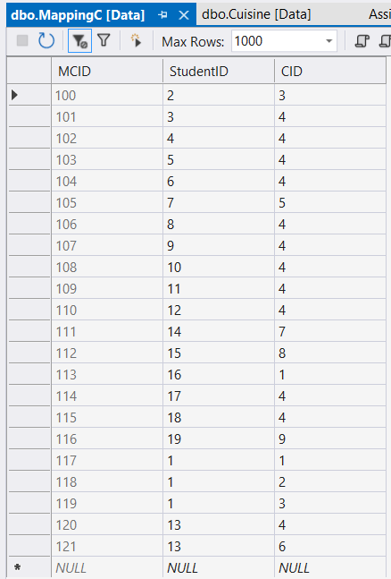 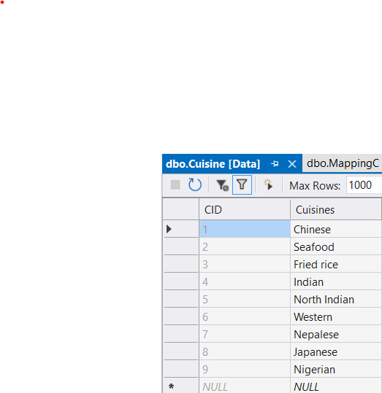

1. Similarly, looking at the column **‘Hobbies’**, there are multi value fields and redundancy present. We will create two tables and insert values in those tables and modify StudentDetails_1 table by removing **‘Hobbies’** Column.

* Hobbies table – HobbyID (Hobby ID) – PK, Hobbies
* MappingHobbies table – MHobbyID (Mapping Hobby ID)-PK, StudentID -FK, Hobby_ID – FK

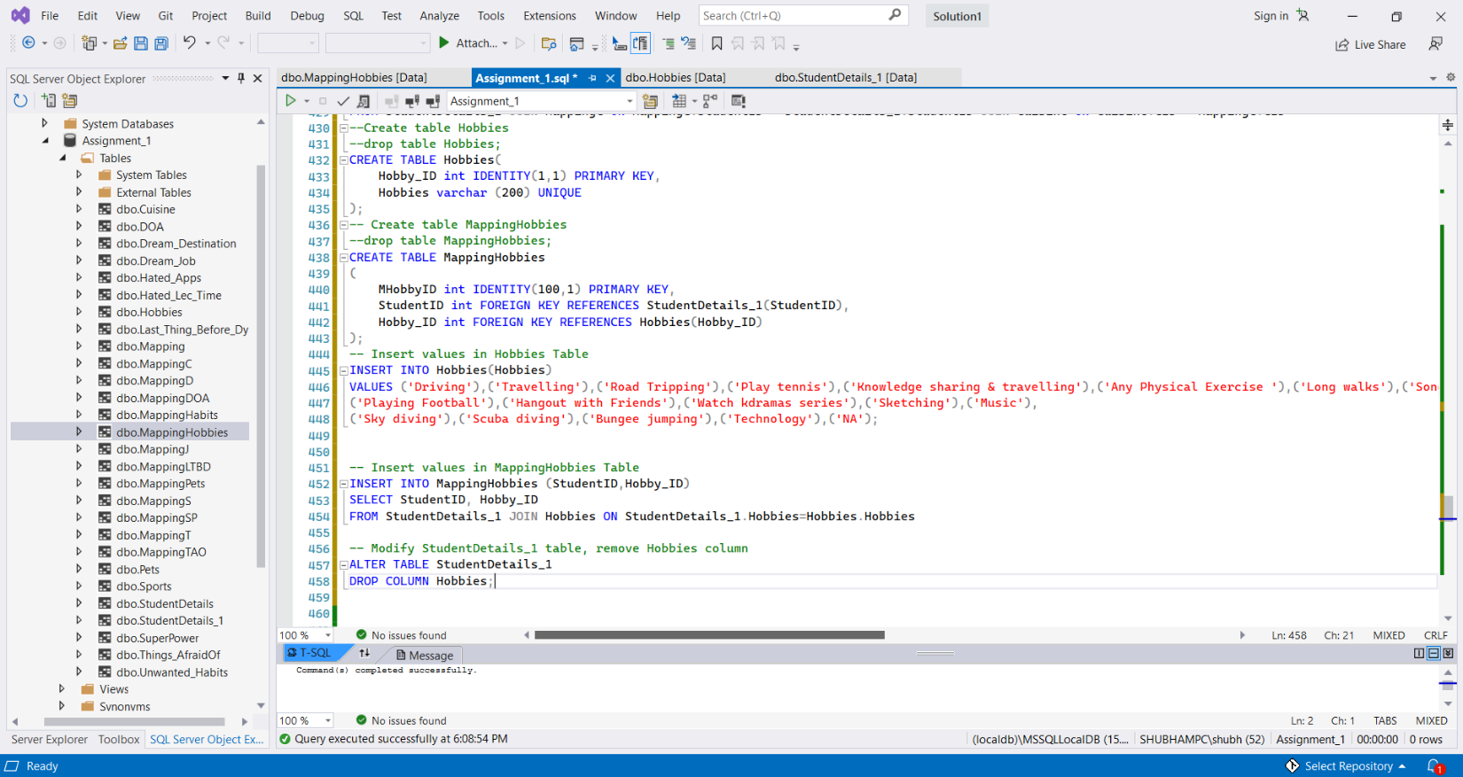

**Hobbies Table** and **MappingHobbies** Table are shown below.

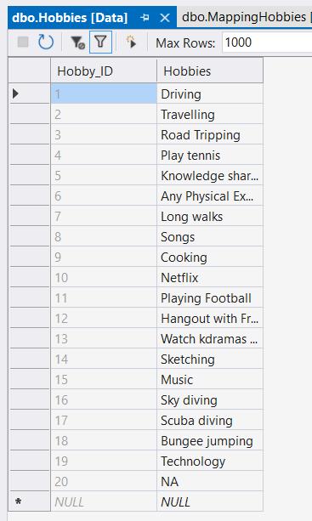 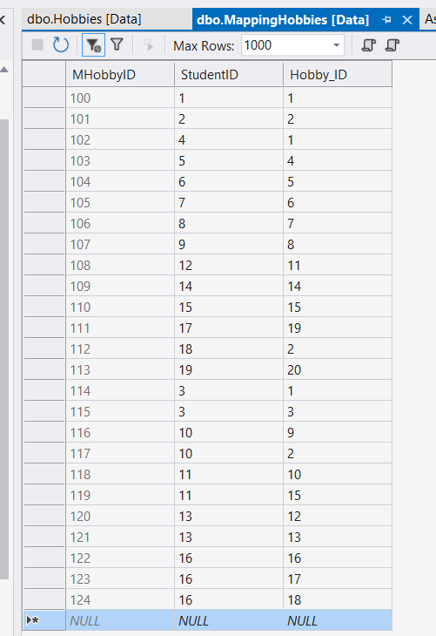

1. Similarly, looking at the column **‘Hobbies’**, there are multi value fields and redundancy present. We will create two tables and insert values in those tables and modify StudentDetails_1 table by removing **‘Hobbies’** Column.

* Hobbies table – HobbyID (Hobby ID) – PK, Hobbies
* MappingHobbies table – MHobbyID (Mapping Hobby ID)-PK, StudentID -FK, Hobby_ID – FK

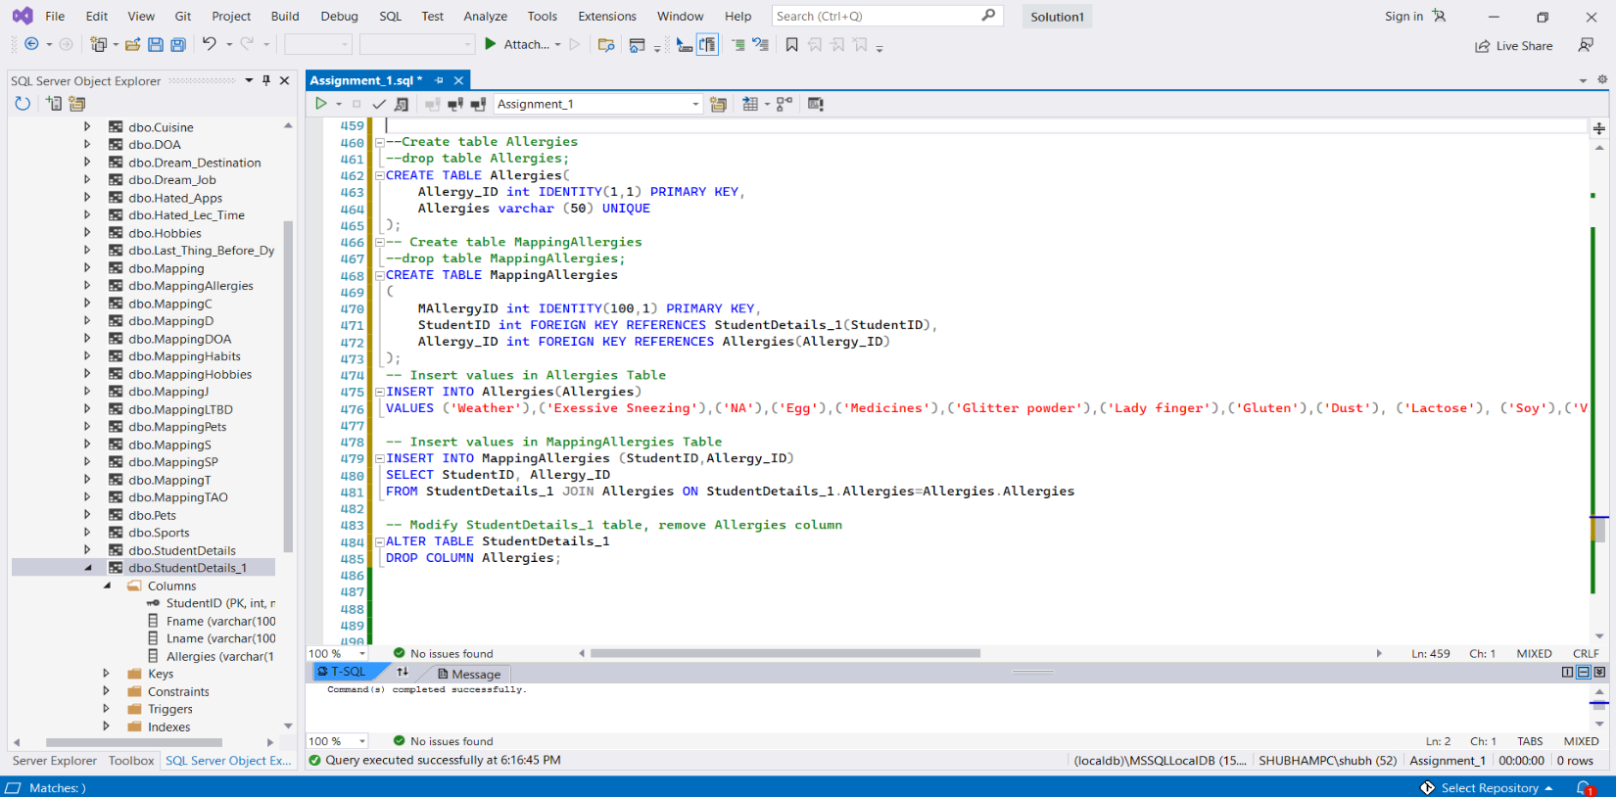

Allergies and MappingAllergies table are shown below,

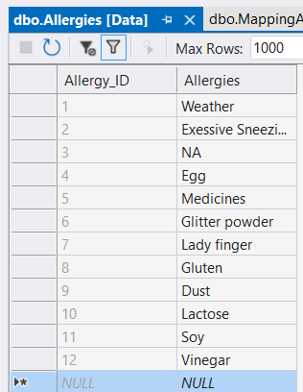 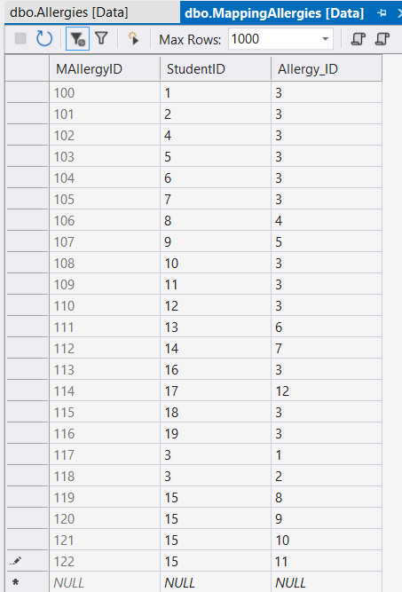

Now our StudentDetails_1 table looks like this after normalization.

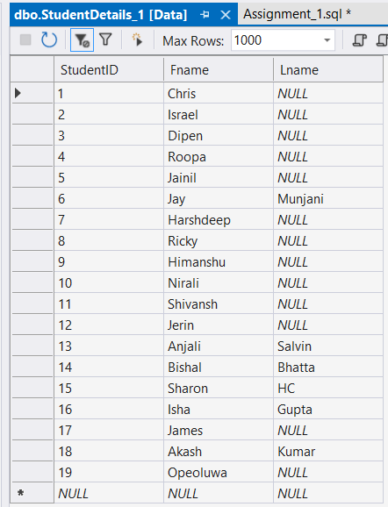

**CONCLUSION**

**After normalization I ended up with 28 new tables (14 for different independent columns and 14 tables for mapping between the new tables and the StudentDetails_1 table).**

**Now the StudentDetails_1 table is in its normalized form.**

**Checking Table connections in the database Assignment_1**

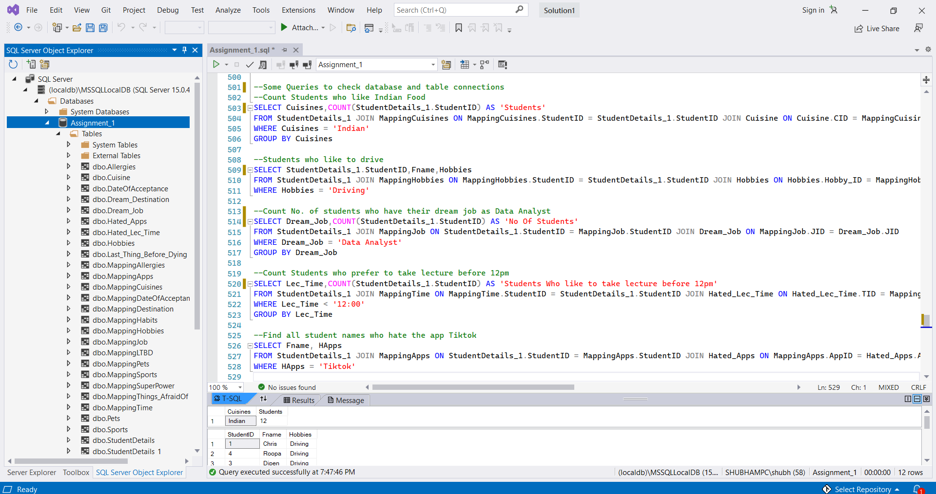

Results from the queries are down below

